**Weekly Status Report – 2018-June-12**

|  |  |
| --- | --- |
| **Project Name** | MLIK |
| **Team Lead** | Jacob Warnes |

|  |  |  |  |  |
| --- | --- | --- | --- | --- |
| **Roles** |  |  |  |  |
| **Week** | **Ashleigh Logan** | **Brendon Waters** | **Isaac Thiessen** | **Jacob Warnes** |
| 01 | Team Lead, Technical Writer, Database/Back-End | Front-End Developer, Technical Writer, Database/Back-End Developer | Technical Writer, Database/Back-End Developer | Technical Writer, Database/Back-End Developer |
| 02 | Front End Developer, Technical Writer | Team Lead, Technical Writer | Backend – Database, Technical Writer | Middleware – PHP, Technical Writer |
| 03 | Front-End/Middleware | Technical Writing | Middleware - PHP, Team Lead | Middleware |
| 04 |  |  |  |  |
| 05 | Middleware –PHP, Front-End | Front-End, Technical writer | Middleware – PHP, Database/Back-End | Team Lead , Technical writer |
| 06 |  |  |  |  |
| 07 |  |  |  |  |
| 08 |  |  |  |  |

|  |
| --- |
| **Weekly Project Summary** |
| Status report completed. . Cart functionality done. New privacy requirement added to BRD and functional on website. |

|  |  |  |  |  |  |
| --- | --- | --- | --- | --- | --- |
| **Key Milestones Status** | | | | | |
| **ID** | **Description** | **Planned Completion** | **Forecasted**  **Completion** | **Actual Completion** | **Status** |
|  | Demo and Deliverables Week 1 Completed | *2018-05-15* | *2018-05-15* | *2018-05-15* | *Complete* |
|  | Demo and Deliverables Week 2 Completed | 2018-05-22 | 2018-05-22 | 2018-05-22 | Complete |
|  | Demo and Deliverables Week 3 Completed | 2018-05-29 | 2018-05-29 | 2018-05-29 | Complete |
|  | Demo and Deliverables Week 4 Completed | 2018-06-05 | 2018-06-05 | 2018-06-05 | Complete |
|  | Demo and Deliverables Week 5 Completed | 2018-06-11 | 2018-06-11 | 2018-06-11 | Complete |
|  | Demo and Deliverables Week 6 Completed | 2018-06-18 | 2018-06-18 |  | Incomplete |
|  | Demo and Deliverables Week 7 Completed | 2018-06-22 | 2018-06-22 |  | Incomplete |

|  |  |  |  |  |  |
| --- | --- | --- | --- | --- | --- |
|  | Final Presentation | 2018-06-22 | 2018-06-22 |  | Incomplete |
|  | Final Report | 2018-06-22 | 2018-06-22 |  | Incomplete |

|  |
| --- |
| **Key Accomplishments for the Week** |
| Week 4 assignments completed  Week 5 assignment’s completed  Users now must accept privacy policy before they can log in  Updated BRD with new change request |

|  |  |  |  |
| --- | --- | --- | --- |
| **Task Assignments for the Coming Week** | | |  |
| **ID** | **Description** | **Assigned To** | **On Schedule** |
| 68-72 | Status report | Ashleigh | Yes |
| 74 | Payment processing | Brendon | Yes |
| 75 | Confirmation email | Isaac | Yes |
| 76 | Order history page | Jacob | Yes |
| 84 | Consistent look and feel | Brendon ,Ashleigh, Isaac ,Jacob | Yes |
|  |  |  |  |
|  |  |  |  |

|  |  |  |
| --- | --- | --- |
| **Tasks Completed in the Previous Week** | |  |
| **ID** | **Description** | **Assigned To** |
| 63 | Privacy Policy | Isaac, Jacob |
| 64 | Delete products from cart | Isaac |
| 65 | Adjust quantity of products from cart | Isaac |
| 66 | Contents saved between sessions | Isaac |
| 56 | Update BRD | Brendon |
| 57-61 | Weekly leader tasks | Jacob |
|  |  |  |

|  |  |
| --- | --- |
| Issues and Risks |  |
| **Description** | **Impact**  **(L,M,H)** |
| Final week approaching | L |
|  |  |
|  |  |

|  |
| --- |
| **Gantt Chart** |

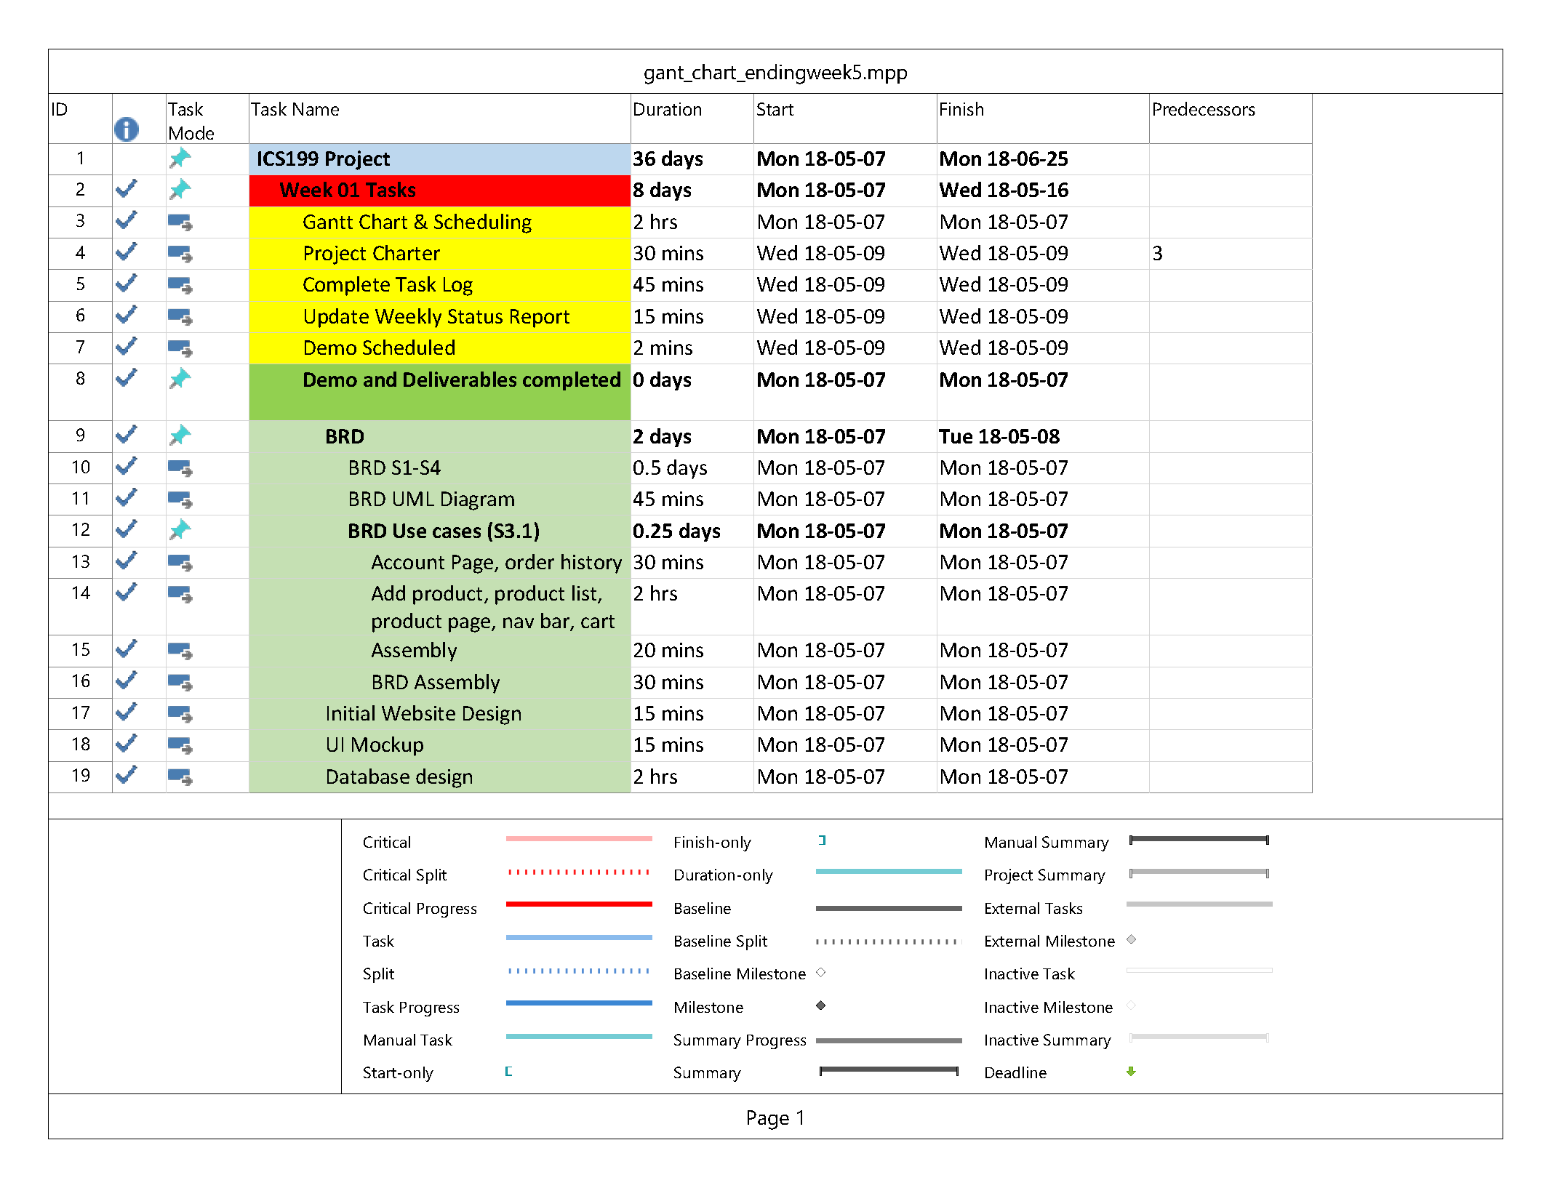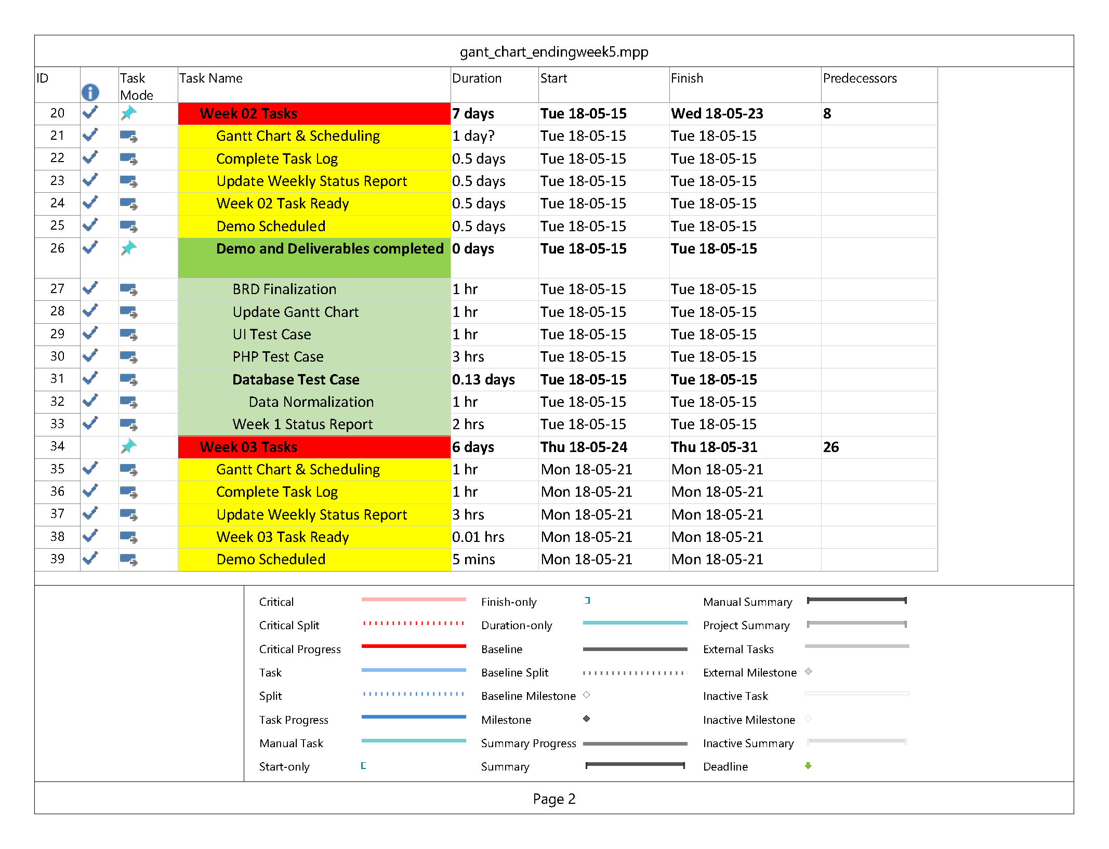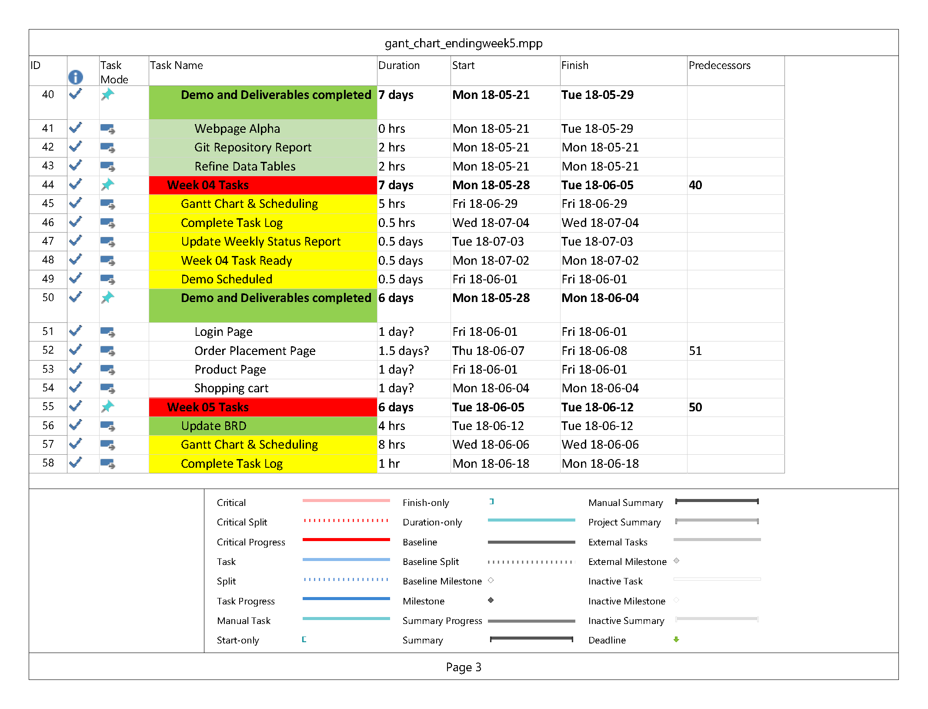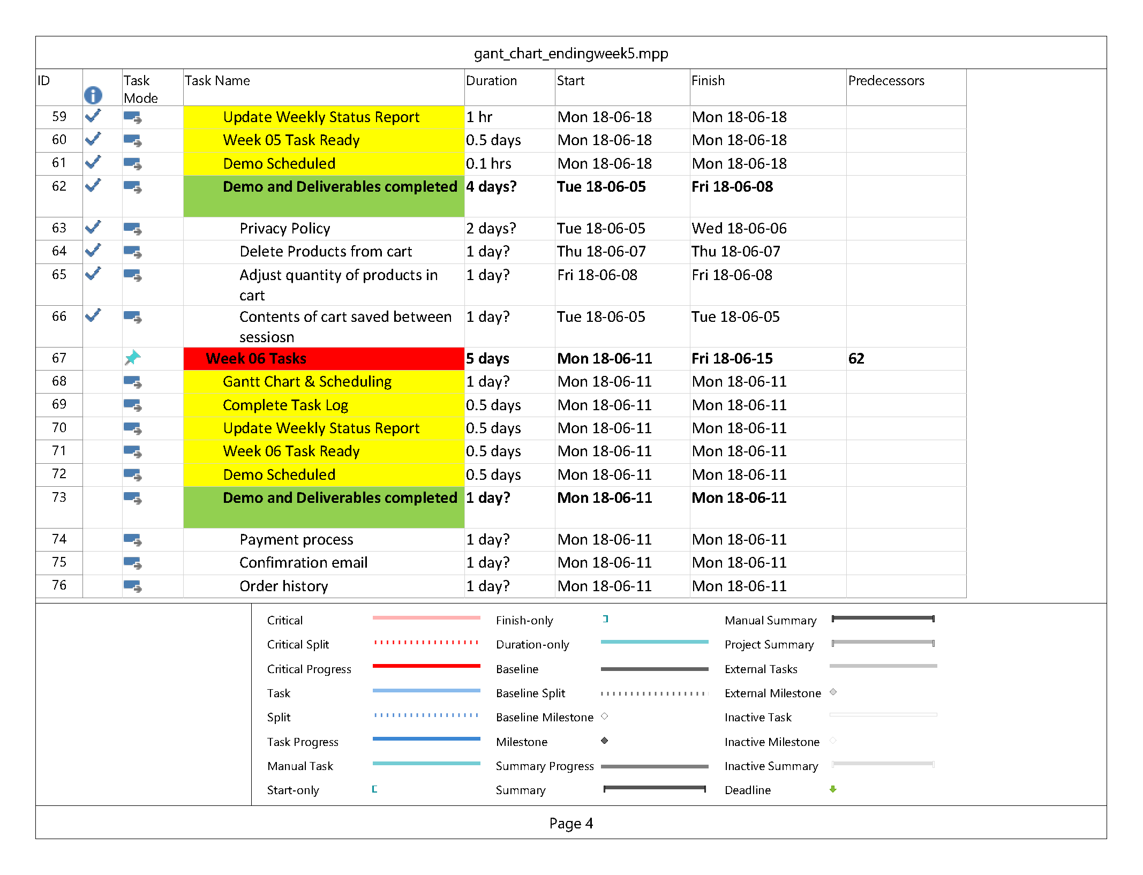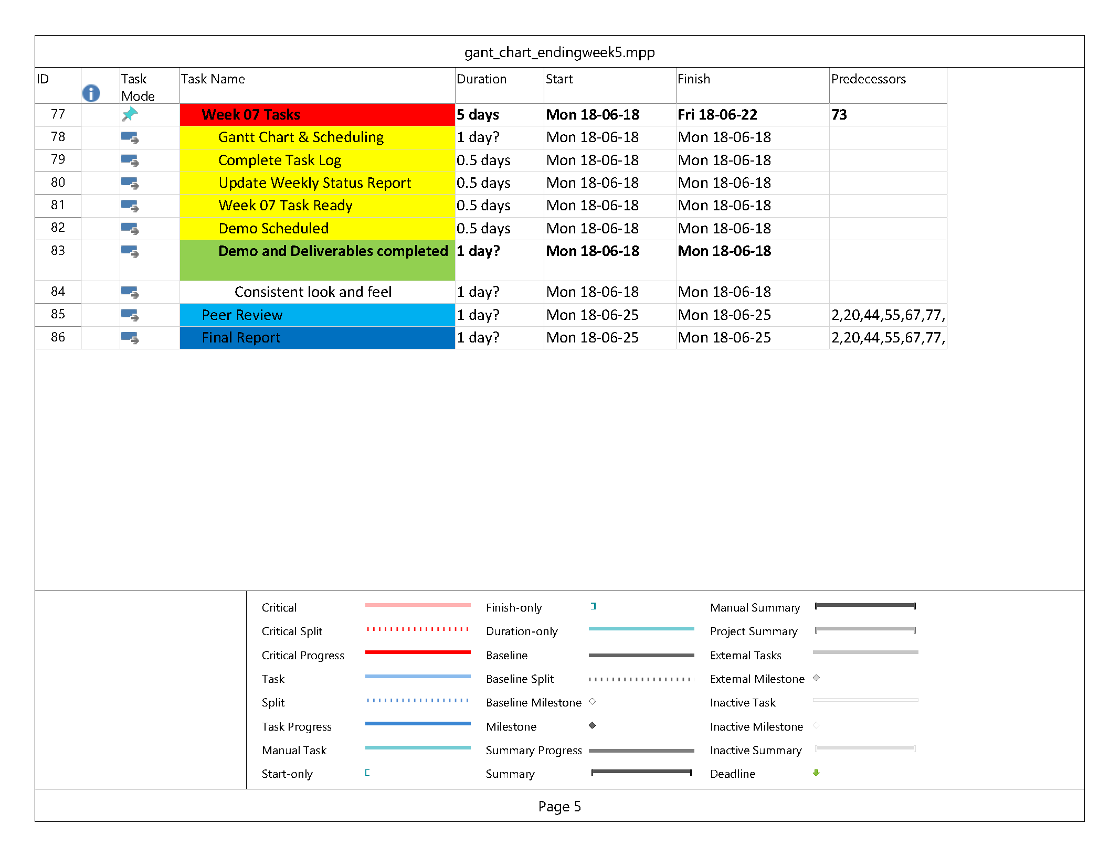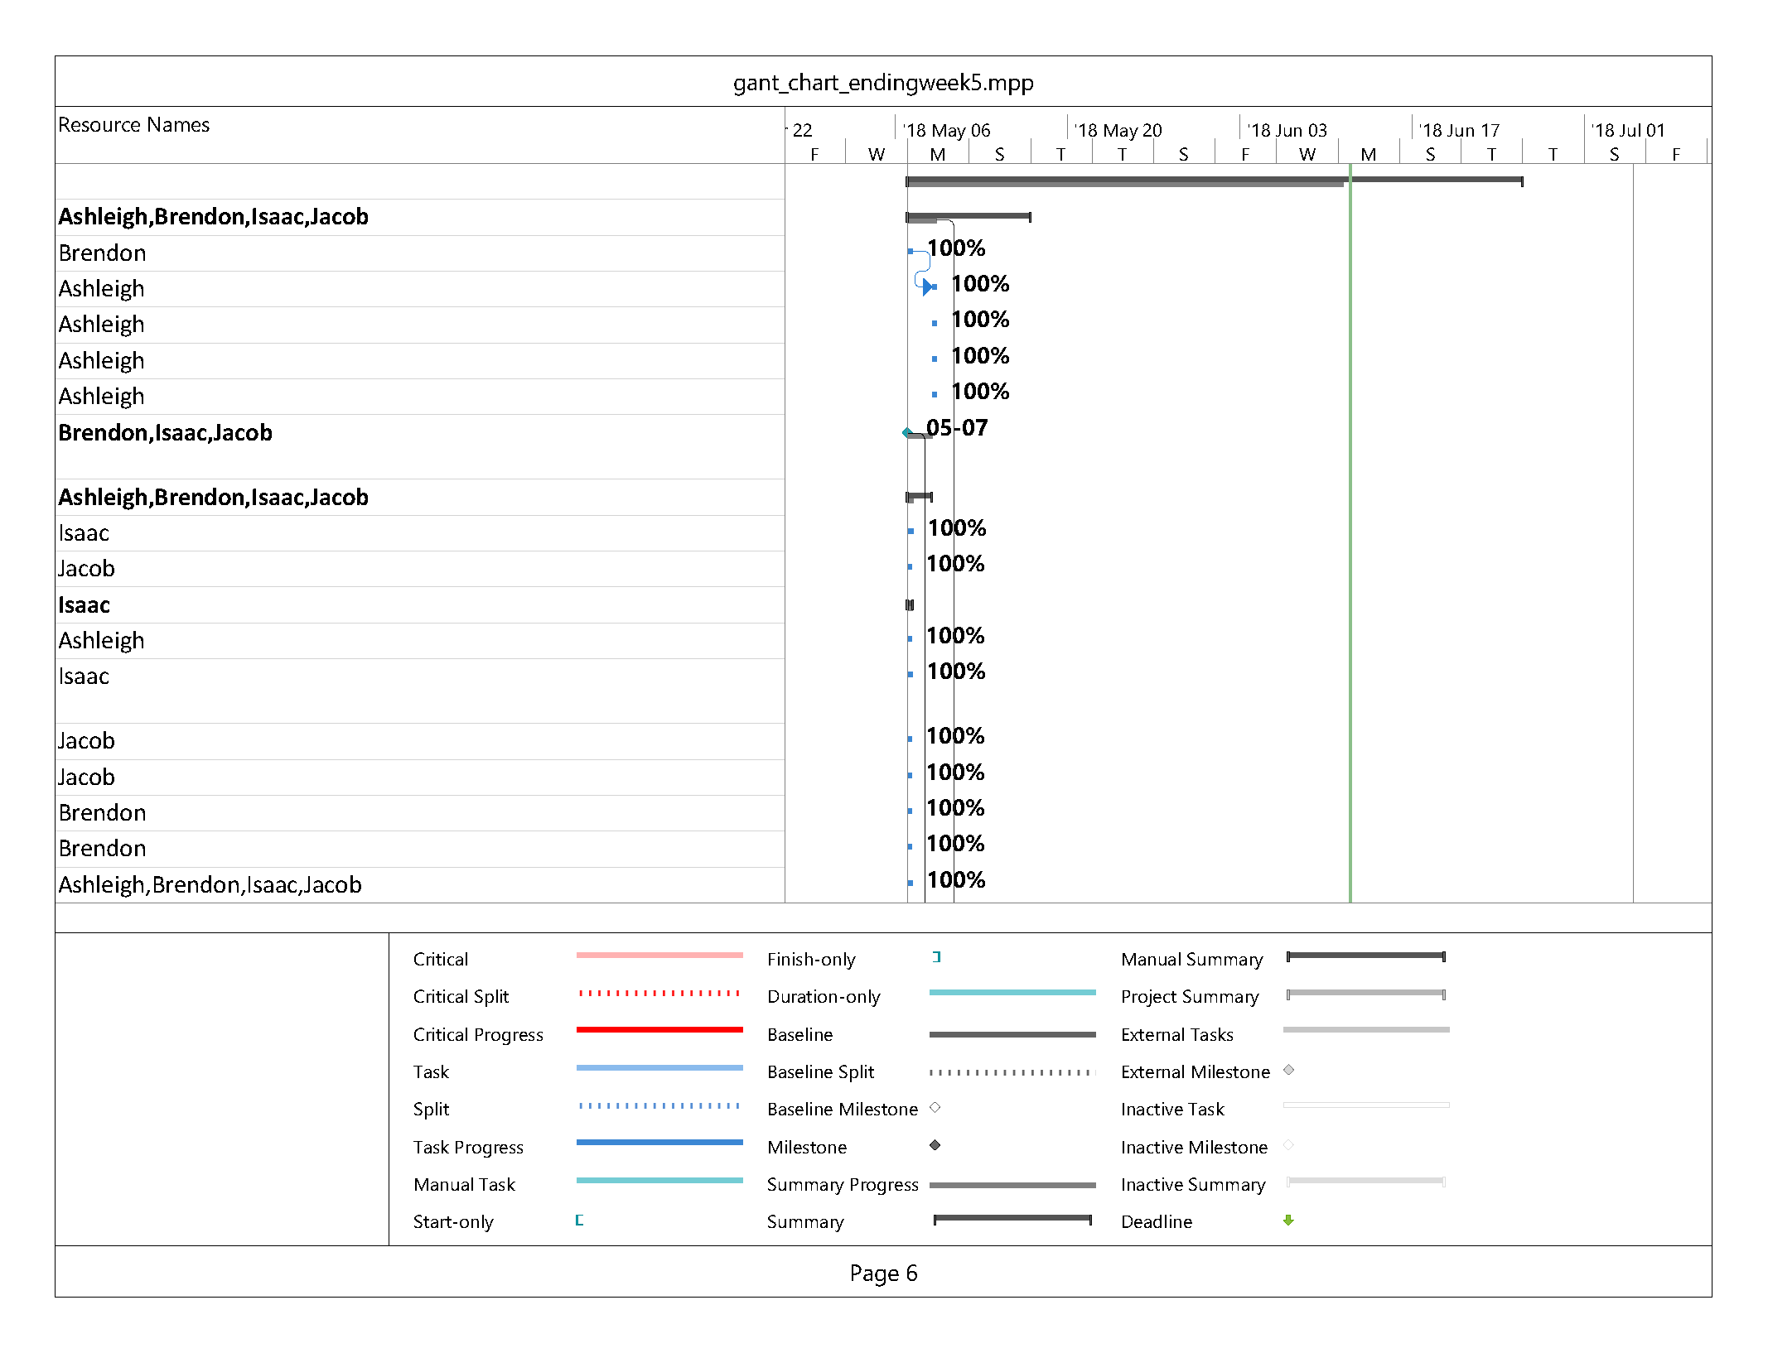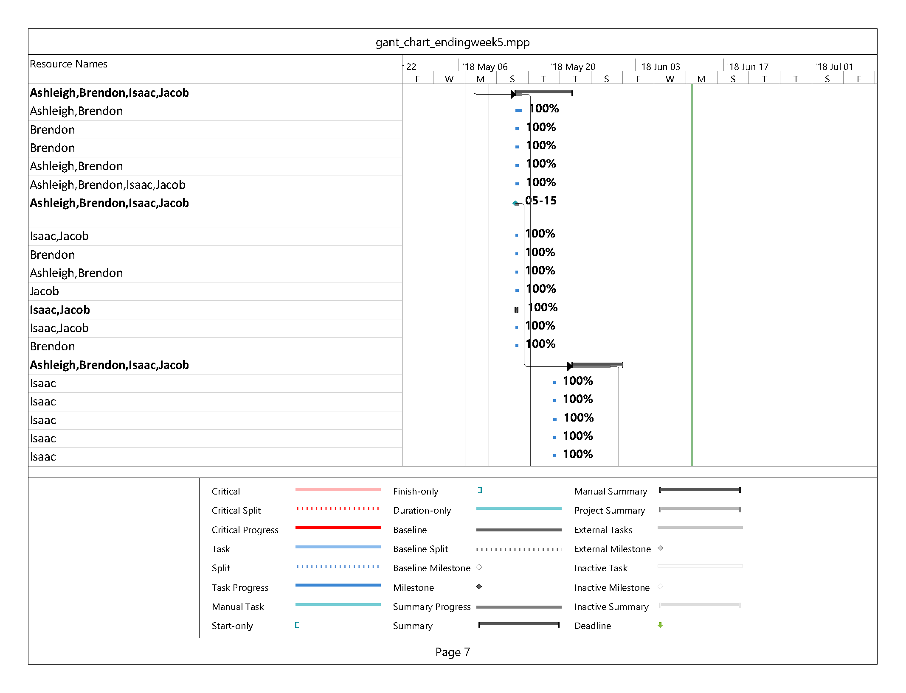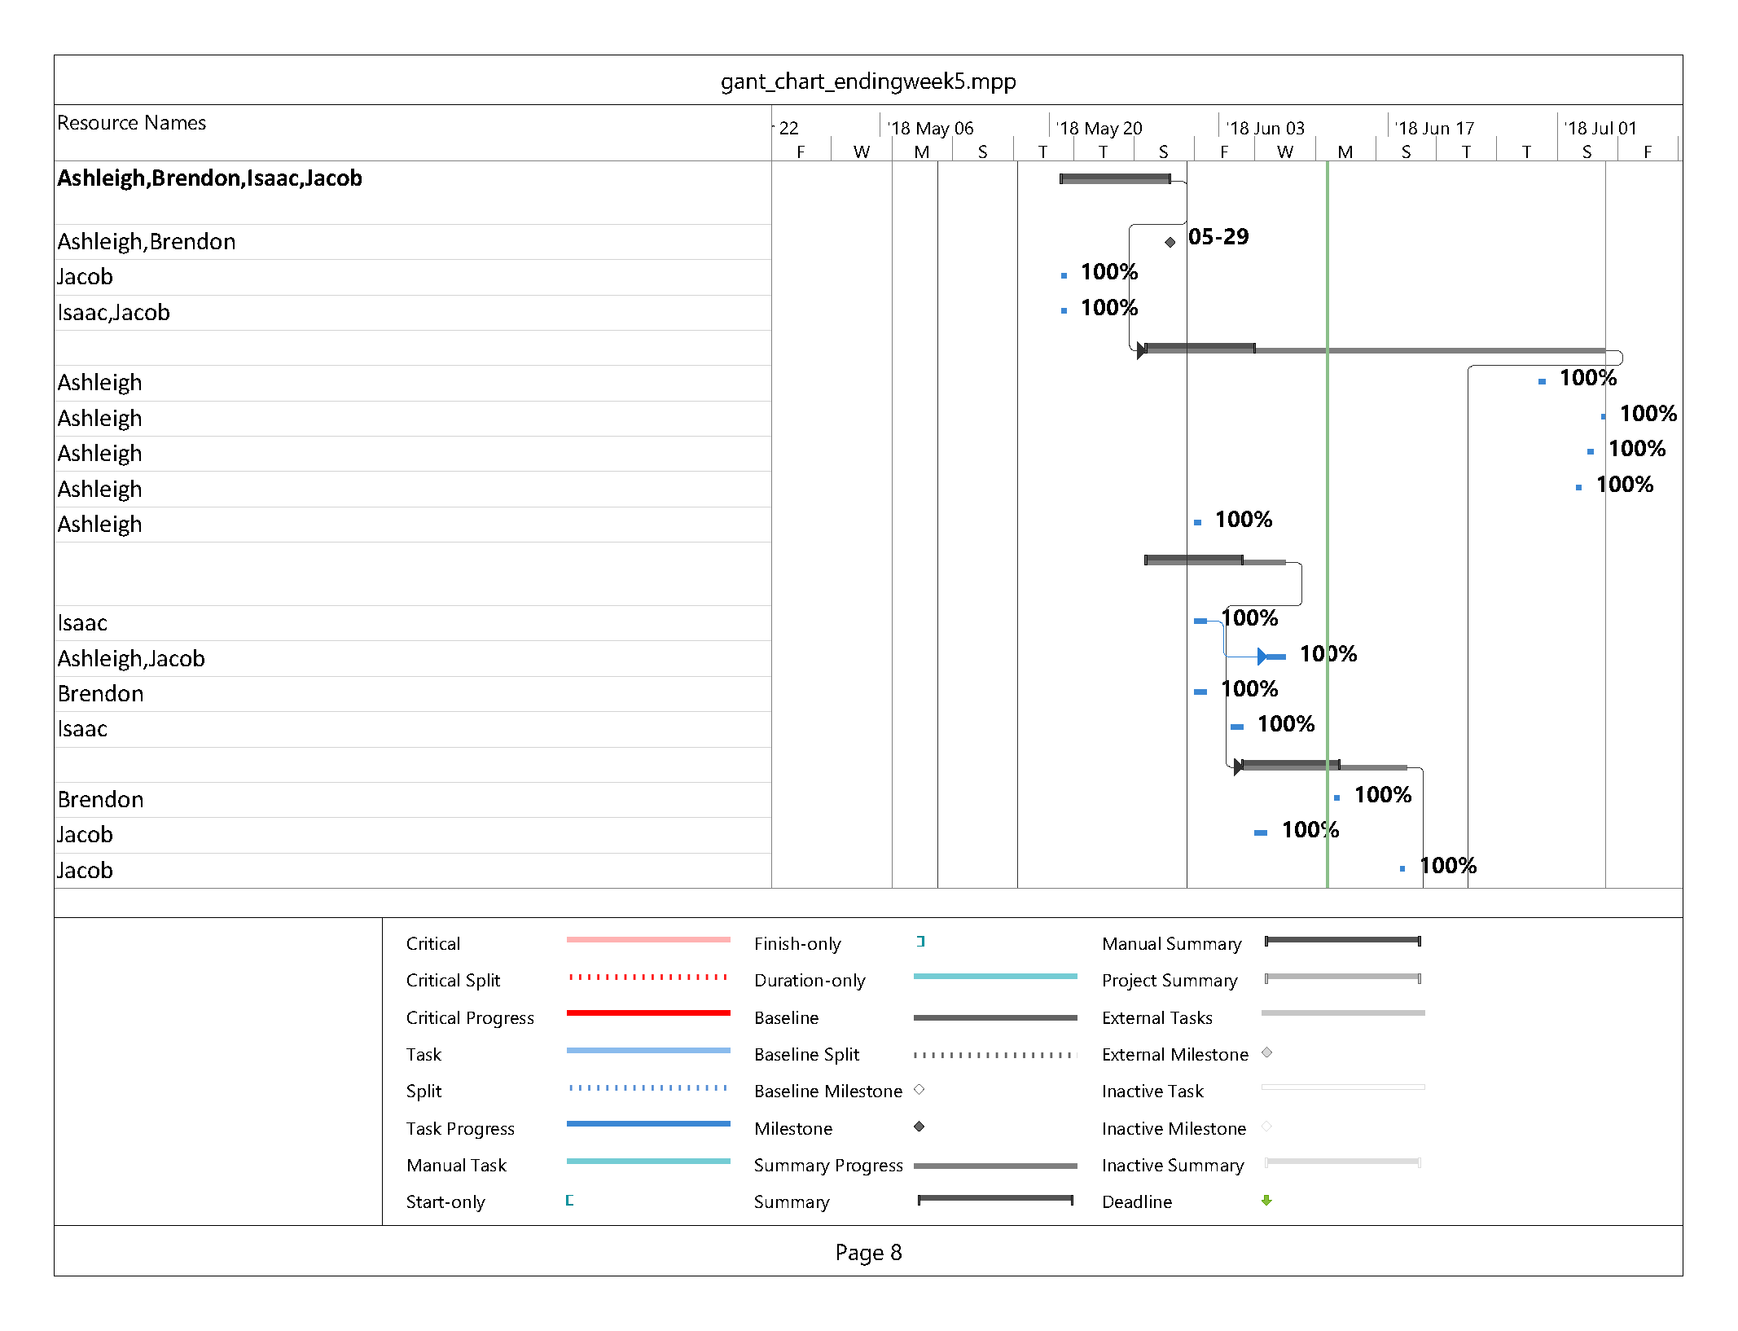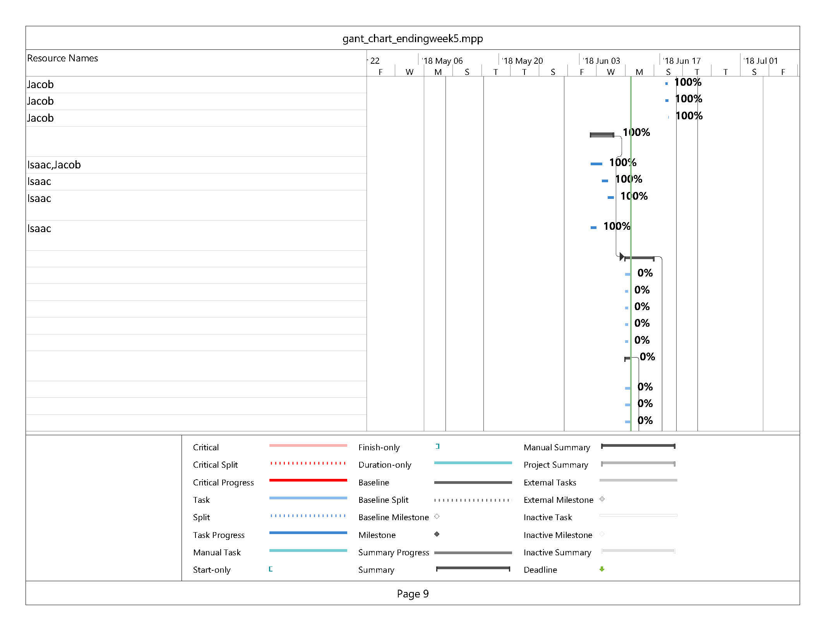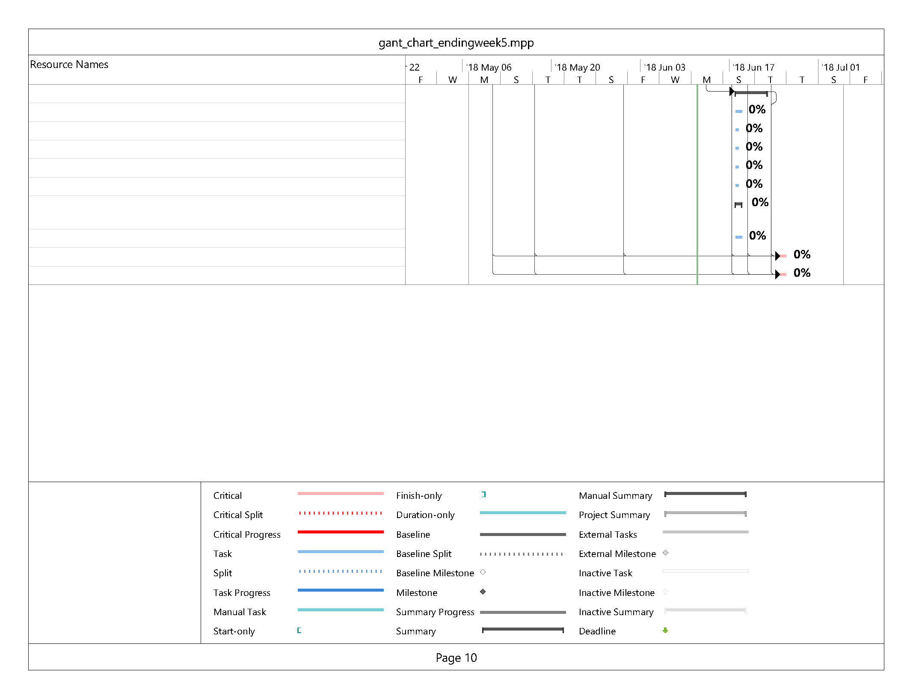

|  |
| --- |
| **Git Log** |

jwarnes:privacy policy page

jwarnes:Merge branch 'master' of https://gitlab.camosun.bc.ca/ics199-2018/group07/website-development-build

jwarnes:login with privacy policy

aal704:updated footer with privacy policy

Isaac Thiessen:made privacy policy page

Isaac Thiessen:Fixed split second page of random css when logging out

Isaac Thiessen:Fixed register issue

Isaac Thiessen:Now displays last login

Isaac Thiessen:Accepting the privacy policy actually works now

Isaac Thiessen:Merge branch 'master' of https://gitlab.camosun.bc.ca/ics199-2018/group07/website-development-build

Isaac Thiessen:Users now must accept the privacy policy

Brendon Waters:BRD final for week of June 5th

Brendon Waters:Merge branch 'master' of https://gitlab.camosun.bc.ca/ics199-2018/group07/website-development-build

Brendon Waters:Incremental update on BRD; file cleanup

jwarnes:updated uml diagrams

jwarnes:new database image and ERD for BRD

Brendon Waters:Merge branch 'master' of https://gitlab.camosun.bc.ca/ics199-2018/group07/website-development-build

Brendon Waters:Updated BRD to include privacy changes. ERD and use case update required still.

Isaac Thiessen:actually fixed functions issue

Isaac Thiessen:attempted functions fix

Isaac Thiessen:policy accepter beta

jwarnes:Merge branch 'master' of https://gitlab.camosun.bc.ca/ics199-2018/group07/website-development-build

jwarnes:login now checks privacy policy

Isaac Thiessen:added set set policy function

Isaac Thiessen:Merge branch 'master' of https://gitlab.camosun.bc.ca/ics199-2018/group07/website-development-build

Isaac Thiessen:added set get last login function

aal704:initial update for stripe payments

Isaac Thiessen:added set last login function

Isaac Thiessen:Merge branch 'master' of https://gitlab.camosun.bc.ca/ics199-2018/group07/website-development-build

Isaac Thiessen:added checkPolicy function

jwarnes:updated EDR

aal704:updated BRD

Brendon Waters:New image added for new product

Brendon Waters:Removed legacy website source files from inital GoogleDrive import.

Brendon Waters:Delete products.html